**DÙNG GITHUB:**

Phần 1: Cài đặt và tạo liên kết chứng thực GITHUB local và GITHUB online

* Địa chỉ tải: <https://git-scm.com/downloads>
* Graphical user interface, application, website

  Description automatically generated
* Cài đặt:
  + Graphical user interface, text, application, email

    Description automatically generated
  + Chọn NEXT
  + Graphical user interface, text, application, email

    Description automatically generated
  + Chọn NEXT tiếp theo
  + Graphical user interface, text, application, email

    Description automatically generated
  + Chọn NEXT
  + Graphical user interface, text, application, email

    Description automatically generated
  + OK thành công
* Tạo tài khoản GITHUB online:
  + Graphical user interface, website

    Description automatically generated
  + Click sign up for GitHub
  + Graphical user interface, application

    Description automatically generated
  + Click chọn continue

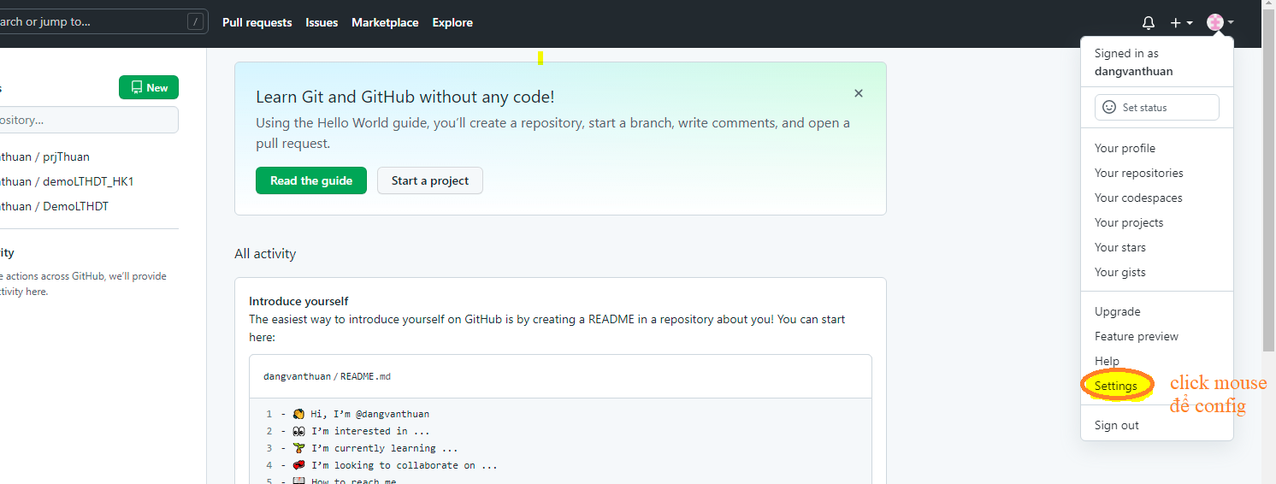

* Chọn theo mục:
* 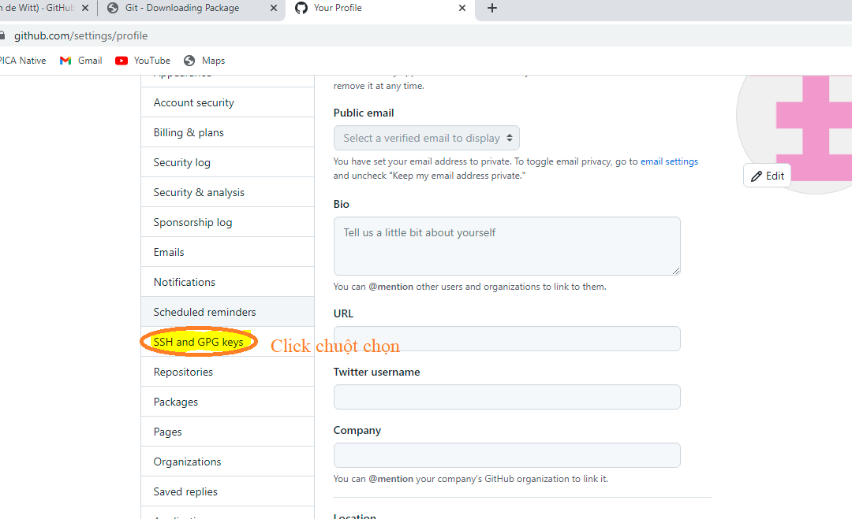
  + Graphical user interface, text, application

    Description automatically generated
  + HÌNH ####
  + Setting: copy SSH từ máy tính của bạn vào:
    - Mở my computer:

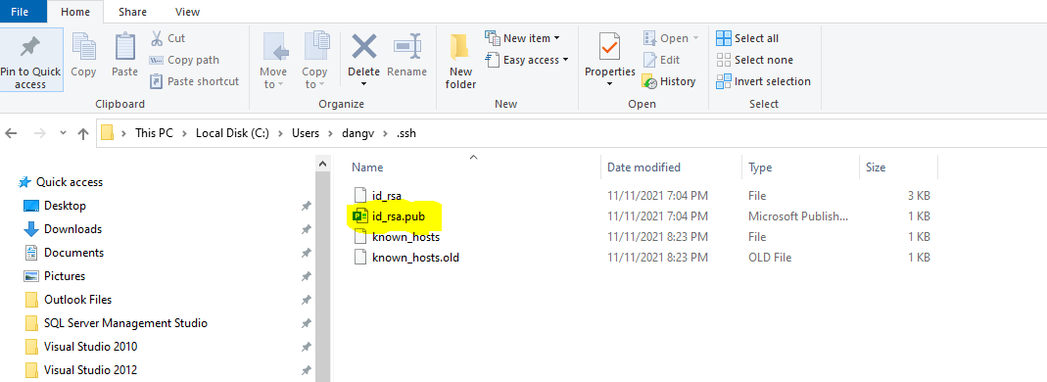

* **Nếu máy tính đang ẩn file phần mở rộng ta cấu hình view option folder:**
  + Graphical user interface, text, application

    Description automatically generated
* **sao cho thấy được đuôi flie:**
  + **Id_rsa.pub**
  + **Mở file này với wordpad lên và chép phần nộp dung dáng vào** HÌNH ####

**Thực hiện liên kết xong giữa máy tính và tài khoản online của github**

* Phần 2: Tạo thư mục chứa project file code
  + Kích chuột phải chuột vào thư mục vừa tạo chọn:
* Text

  Description automatically generated

**Step 1: Tạo Repository để lưu code offline**

- CMD: git init

**step 2: xem trạng thái Repository**

- CMD: git status

**step 3: Tạo nhánh mới có tên develop**

- CMD: git checkout -b develop

**step 4: Đưa file vào môi trường github:**

- CMD: git add <tên file> // Đưa một file vào môi trường github

- CMD: git add . // Đưa tất cả các file vào môi trường github

- CMD: git commit -m “lần xác nhận” // xác nhận file vào môi trường github nhớ close các file

**step 5: Ðưa lên online github:**

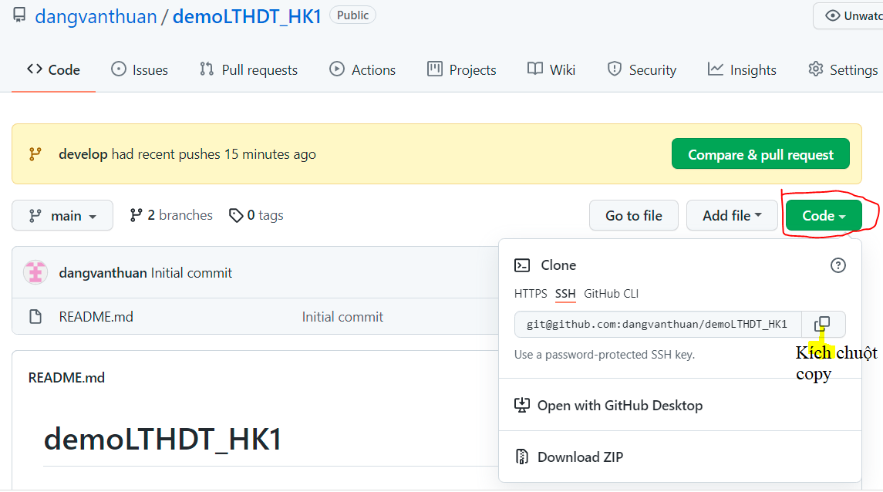

- CMD: git remote add dautien [git@github.com:dangvanthuan/demoLTHDT_HK1.git//](mailto:git@github.com:dangvanthuan/demoLTHDT_HK1.git//) chép code liên kết:

**step 6: xem kết quả:**

- CMD: git remote -v

$ git remote -v

dautien git@github.com:dangvanthuan/demoLTHDT_HK1.git (fetch)

dautien git@github.com:dangvanthuan/demoLTHDT_HK1.git (push)

**kết thúc:**

$ git push dautien develop

The authenticity of host 'github.com (20.205.243.166)' can't be established.

RSA key fingerprint is SHA256:nThbg6kXUpJWGl7E1IGOCspRomTxdCARLviKw6E5SY8.

This key is not known by any other names

Are you sure you want to continue connecting (yes/no/[fingerprint])? y

Please type 'yes', 'no' or the fingerprint: yes

Warning: Permanently added 'github.com' (RSA) to the list of known hosts.

Enumerating objects: 4, done.

Counting objects: 100% (4/4), done.

Delta compression using up to 4 threads

Compressing objects: 100% (3/3), done.

Writing objects: 100% (4/4), 336 bytes | 112.00 KiB/s, done.

Total 4 (delta 0), reused 0 (delta 0), pack-reused 0

remote:

remote: Create a pull request for 'develop' on GitHub by visiting:

remote: https://github.com/dangvanthuan/demoLTHDT_HK1/pull/new/develop

remote:

To github.com:dangvanthuan/demoLTHDT_HK1.git

* [new branch] develop -> develop

**step 7: Tạo nhánh cho repository:**

- CMD: git checkout -b <tên nhánh> hoặc nhánh con theo <nhanh1/nhanh2>

dangv@PAUL MINGW64 /d/GitProjectCode/code (develop)

$ git checkout -b develop2/develop3

Switched to a new branch 'develop2/develop3'

- CMD: git checkout <tên nhánh> // về nhánh mẹ

Step 8: xóa nhánh :

-CMD: git branch -d <tên nhánh>

Các cú pháp câu lệnh

dangv@PAUL MINGW64 /c/baitap (baitapv1)

$ git status -?

error: unknown switch `?'

usage: git status [<options>] [--] <pathspec>...

-v, --verbose be verbose

-s, --short show status concisely

-b, --branch show branch information

--show-stash show stash information

--ahead-behind compute full ahead/behind values

--porcelain[=<version>]

machine-readable output

--long show status in long format (default)

-z, --null terminate entries with NUL

-u, --untracked-files[=<mode>]

show untracked files, optional modes: all, normal, no. (Default: all)

--ignored[=<mode>] show ignored files, optional modes: traditional, matching, no. (Default: traditional)

--ignore-submodules[=<when>]

ignore changes to submodules, optional when: all, dirty, untracked. (Default: all)

--column[=<style>] list untracked files in columns

--no-renames do not detect renames

-M, --find-renames[=<n>]

detect renames, optionally set similarity index

--show-ignored-directory

(DEPRECATED: use --ignore=matching instead) Only show directories that match an ignore pattern name.

--no-lock-index (DEPRECATED: use `git --no-optional-locks status` instead) Do not lock the index

dangv@PAUL MINGW64 /c/baitap (baitapv1)

$ git init -?

error: unknown switch `?'

usage: git init [-q | --quiet] [--bare] [--template=<template-directory>] [--shared[=<permissions>]] [<directory>]

--template <template-directory>

directory from which templates will be used

--bare create a bare repository

--shared[=<permissions>]

specify that the git repository is to be shared amongst several users

-q, --quiet be quiet

--separate-git-dir <gitdir>

separate git dir from working tree

-b, --initial-branch <name>

override the name of the initial branch

--object-format <hash>

specify the hash algorithm to use

dangv@PAUL MINGW64 /c/baitap (baitapv1)

$ git checkout -?

error: unknown switch `?'

usage: git checkout [<options>] <branch>

or: git checkout [<options>] [<branch>] -- <file>...

-b <branch> create and checkout a new branch

-B <branch> create/reset and checkout a branch

-l create reflog for new branch

--guess second guess 'git checkout <no-such-branch>' (default)

--overlay use overlay mode (default)

-q, --quiet suppress progress reporting

--recurse-submodules[=<checkout>]

control recursive updating of submodules

--progress force progress reporting

-m, --merge perform a 3-way merge with the new branch

--conflict <style> conflict style (merge or diff3)

-d, --detach detach HEAD at named commit

-t, --track set upstream info for new branch

-f, --force force checkout (throw away local modifications)

--orphan <new-branch>

new unparented branch

--overwrite-ignore update ignored files (default)

--ignore-other-worktrees

do not check if another worktree is holding the given ref

-2, --ours checkout our version for unmerged files

-3, --theirs checkout their version for unmerged files

-p, --patch select hunks interactively

--ignore-skip-worktree-bits

do not limit pathspecs to sparse entries only

--pathspec-from-file <file>

read pathspec from file

--pathspec-file-nul with --pathspec-from-file, pathspec elements are separated with NUL character

dangv@PAUL MINGW64 /c/baitap (baitapv1)

$ git branch -?

error: unknown switch `?'

usage: git branch [<options>] [-r | -a] [--merged] [--no-merged]

or: git branch [<options>] [-l] [-f] <branch-name> [<start-point>]

or: git branch [<options>] [-r] (-d | -D) <branch-name>...

or: git branch [<options>] (-m | -M) [<old-branch>] <new-branch>

or: git branch [<options>] (-c | -C) [<old-branch>] <new-branch>

or: git branch [<options>] [-r | -a] [--points-at]

or: git branch [<options>] [-r | -a] [--format]

Generic options

-v, --verbose show hash and subject, give twice for upstream branch

-q, --quiet suppress informational messages

-t, --track set up tracking mode (see git-pull(1))

-u, --set-upstream-to <upstream>

change the upstream info

--unset-upstream unset the upstream info

--color[=<when>] use colored output

-r, --remotes act on remote-tracking branches

--contains <commit> print only branches that contain the commit

--no-contains <commit>

print only branches that don't contain the commit

--abbrev[=<n>] use <n> digits to display object names

Specific git-branch actions:

-a, --all list both remote-tracking and local branches

-d, --delete delete fully merged branch

-D delete branch (even if not merged)

-m, --move move/rename a branch and its reflog

-M move/rename a branch, even if target exists

-c, --copy copy a branch and its reflog

-C copy a branch, even if target exists

-l, --list list branch names

--show-current show current branch name

--create-reflog create the branch's reflog

--edit-description edit the description for the branch

-f, --force force creation, move/rename, deletion

--merged <commit> print only branches that are merged

--no-merged <commit> print only branches that are not merged

--column[=<style>] list branches in columns

--sort <key> field name to sort on

--points-at <object> print only branches of the object

-i, --ignore-case sorting and filtering are case insensitive

--format <format> format to use for the output

dangv@PAUL MINGW64 /c/baitap (baitapv1)

$ git add -?

error: unknown switch `?'

usage: git add [<options>] [--] <pathspec>...

-n, --dry-run dry run

-v, --verbose be verbose

-i, --interactive interactive picking

-p, --patch select hunks interactively

-e, --edit edit current diff and apply

-f, --force allow adding otherwise ignored files

-u, --update update tracked files

--renormalize renormalize EOL of tracked files (implies -u)

-N, --intent-to-add record only the fact that the path will be added later

-A, --all add changes from all tracked and untracked files

--ignore-removal ignore paths removed in the working tree (same as --no-all)

--refresh don't add, only refresh the index

--ignore-errors just skip files which cannot be added because of errors

--ignore-missing check if - even missing - files are ignored in dry run

--chmod (+|-)x override the executable bit of the listed files

--pathspec-from-file <file>

read pathspec from file

--pathspec-file-nul with --pathspec-from-file, pathspec elements are separated with NUL character

dangv@PAUL MINGW64 /c/baitap (baitapv1)

$ git commit -?

error: unknown switch `?'

usage: git commit [<options>] [--] <pathspec>...

-q, --quiet suppress summary after successful commit

-v, --verbose show diff in commit message template

Commit message options

-F, --file <file> read message from file

--author <author> override author for commit

--date <date> override date for commit

-m, --message <message>

commit message

-c, --reedit-message <commit>

reuse and edit message from specified commit

-C, --reuse-message <commit>

reuse message from specified commit

--fixup [(amend|reword):]commit

use autosquash formatted message to fixup or amend/reword specified commit

--squash <commit> use autosquash formatted message to squash specified commit

--reset-author the commit is authored by me now (used with -C/-c/--amend)

--trailer <trailer> add custom trailer(s)

-s, --signoff add a Signed-off-by trailer

-t, --template <file>

use specified template file

-e, --edit force edit of commit

--cleanup <mode> how to strip spaces and #comments from message

--status include status in commit message template

-S, --gpg-sign[=<key-id>]

GPG sign commit

Commit contents options

-a, --all commit all changed files

-i, --include add specified files to index for commit

--interactive interactively add files

-p, --patch interactively add changes

-o, --only commit only specified files

-n, --no-verify bypass pre-commit and commit-msg hooks

--dry-run show what would be committed

--short show status concisely

--branch show branch information

--ahead-behind compute full ahead/behind values

--porcelain machine-readable output

--long show status in long format (default)

-z, --null terminate entries with NUL

--amend amend previous commit

--no-post-rewrite bypass post-rewrite hook

-u, --untracked-files[=<mode>]

show untracked files, optional modes: all, normal, no. (Default: all)

--pathspec-from-file <file>

read pathspec from file

--pathspec-file-nul with --pathspec-from-file, pathspec elements are separated with NUL character